**Please check the monthly class board. Class type, times & instructors are subject to change.**

**Revised June 10, 2025 412-364-8500**

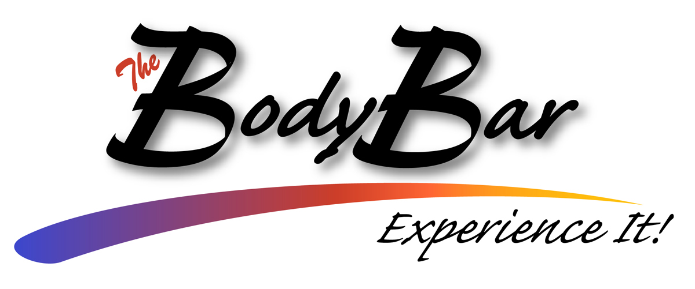

|  |  |  |  |  |  |
| --- | --- | --- | --- | --- | --- |
| **Mon** | **Tues** | **Wed** | **Thur** | **Fri** | **Sat** |
| **•8:10am•**  **YOGA**  w/Angie  **•9:15am•**  ***SENIOR***  **CARDIO CIRCUIT**  w/Marcia  **•10:15am•**  ***SENIOR***  **CARDIO CIRCUIT** w/Marcia    **•11:15am•**  ***SENIOR***  **Classic**  w/Marcia  **•12:30pm• LINE DANCING**  w/Shirley    **•6:00pm•**  **CARDIO SCULPT**  w/Megan  **•7:00pm•**  **YOGA**  w/Michele | **•8:10am•**  **Barre**  w/Betty  **•9:00am•**  **ZUMBA**®  w/Betty  **•10:15am•**  **BRAINS & BALANCE**  w/Nancy  **•11:15am•**  ***SENIOR***  **YOGA** w/Nancy  **•12:30pm• LINE DANCING**  w/Shirley  **•6:00pm**  **STRENGTH**  **TRAINING**  w/Hannah  **•7:00pm**  **Zumba**  w/Betty | **•8:10am•**  **YOGA**  w/Jon  **•9:15am•**  ***SENIOR***  **Boom Muscle**  w/Nancy  **•10:15am•**  ***SENIOR***  **CARDIO CIRCUIT** w/Nancy  **•11:15am•**  ***SENIOR***  **Classic** w/Nancy  **A person meditating in a yoga pose  AI-generated content may be incorrect.** | **•8:10am•**  **CIRCUIT TRAINING**  w/Betty  **•9:00am•**  **ZUMBA**®  w/Betty  **•10:15am•**  ***SENIOR***  **Strength & Stretch**  w/Rose  **•11:15am•**  ***SENIOR***  **Classic**  w/Suzy  Elderly Couple Doing Sports With Dumbbells Together Vector. Isolated  Illustration 17391598 Vector Art at Vecteezy  **•6:00pm•**  **YOGA**  w/Alyssa | **•8:10am**•  **CARDIO SCULPT**  w/Betty  **•9:15am•**  ***SENIOR***  **CARDIO CIRCUIT**  w/Marcia  **•10:15am•**  ***SENIOR***  **CARDIO CIRCUIT**  w/Marcia  **•11:15am•**  ***SENIOR***  **Classic**  w/Marcia  **Non-MEMBER**  **CLASS pricing**  **• 1 class - $5**  **• 5 CLASSES -$25 Get 1 Free!**  **• 10 classes -**  **$50 Get 2 FREE!** | **•8:10am•**  **YOGA**  w/Jon    **•9:10am•**  **Zumba®**  w/Betty, Dabney, or Anne    **CLASSES ARE FREE**  **WITH YOUR FITNESS**  **MEMBERSHIP 😊** |

**HOURS: Mon-Thurs. 8am – 8pm**

**Fri. 8am-5pm Sat. 8am-4pm Sun.- Closed**

**CLASSES FOR ALL FITNESS LEVELS**

* **BARRE:** Sculpt, tone & slim your entire body with this mix of Pilates, dance, yoga, and functional training moves, that focus on your core using the ballet barre.
* **CIRCUIT TRAINING:** Circuit Training is a class for all fitness levels and abilities. Resistance, cardio-metabolic, and core training engages all muscle groups, leaving you feeling energized!
* **LINE DANCING:** This class is for all those who enjoy dancing or have always wanted to learn some of the most popular line dances. The class is designed for both men & women, but you do not need to have a partner. Good exercise and lots of fun!
* **CARDIO SCULPT**: This great heart-pumping, fat burning, cardio workout is designed to reshape and tone your muscles. These total body conditioning, hardcore cardiovascular workouts are followed by a complete resistance training program.
* **TOTAL BODY & ABS:** A cardio core workout that burns fat, tones abdominal muscles, maintains a strong core, and improves posture. Bring your mat!
* **YOGA:** Yoga involves postures or “asanas” that energize and tone the body. Yoga trains the mind to focus and be fully present through concentration and deep relaxation. This class is appropriate for all levels and offers a safe and contemporary approach to this classical discipline.
* **ZUMBA®:** Zumba is Columbian slang meaning “to move fast to music”. Motivating music makes this exercise class fun and easy to do! Zumba is an intense workout based around Latin dance steps, including Meringue, Salsa, Hip-Hop, Mambo & more.
* **STRENGTH TRAINING:** Strength training, also known as resistance training, involves the use of weights, body weight, or resistance bands to make muscles work harder and become stronger.

**CLASSES SPECIFICALLY for SENIOR LEVEL FITNESS**

* **SENIOR CLASSIC:** Designed to increase muscle strength, range of movement, and improve activities for daily living. A chair is used for seated exercises and standing support and class can be modified depending on fitness levels.
* **SENIOR CARDIO CIRCUIT:** The Senior Cardio Circuit workout offers standing, low-impact choreography alternated with standing upper-body strength work with hand-held weights, elastic tubing with handles and a SENIOR ball. A chair is available for standing support.
* **SENIOR STRENGTH & STRETCH:** Move through a complete series of seated and standing exercises. Chair support is offered so you can perform a variety of movements designed to increase flexibility, balance, and muscle tone. This class is suitable for nearly every fitness level.
* **BOOM MUSCLE:** Muscle incorporates athletic-based exercises that improve upper body conditioning. You’ll move through several “blocks,” which are groups of exercises that focus on different muscle groups. The focus of this class is on toning muscles and building overall strength.
* **BRAINS & BALANCE:** Is designed to help you become stronger while improving your balance to help prevent falls. Specific exercises are taught in class to improve muscle strength, power around the ankle, knee, and hip joints, while improving your reaction time. Every fitness level can adapt to the skills of this class.